|  |
| --- |
| **Concordia University**  **Department of Computer Science**  **and Software Engineering** |

|  |
| --- |
| **Touch For Food** |

|  |
| --- |
| **Analysis** |

|  |
| --- |
| **SOEN 490**  **Capstone Project**  **Fall 2012 – Winter 2013** |

|  |  |
| --- | --- |
| **CloudNine** |  |
| Josh Hum (Team Leader) | 9583157 |
| Katrina Anderson | 9106251 |
| Cristian Asenjo | 9280014 |
| Christian Daher | 9599673 |
| Cynthia Donato | 9353852 |
| Mikhail Levkovsky | 9583165 |
| Patrick Modafferi | 9401377 |
| Ryan Nasr | 9605614 |
| Matthew Tam | 9675701 |

**Table of Contents**

1 Introduction 6

2 Fully Dressed Use Cases 7

UC25.1 Place Order 7

UC26.1 View Menu 9

UC27.1 Manage Menu 10

UC29.1 Deliver Order Item 11

UC34.1 Service Request 12

UC34.2 Service Request Response 13

UC35.1 Create User Profile 14

UC35.2 Login to Personal Profile 15

UC35.3 Update User Settings 16

UC36.1 Generate Report 17

UC39.1 Submit a Review 18

UC42.1 Manage Bill 19

UC192.1 Manage Tables 20

UC279.1 Lookup Customer Restaurant and Order History 21

3 Domain Model 22

4 System Sequence Diagrams 23

SSD25.1 Place Order 23

SSD27.1 Manage Menu 24

SSD34.1 Service Request 25

SSD34.2 Service Request Response 25

SSD35.1 Login to Personal Profile 26

SSD39.1 Submit a Review 26

5 System Operations 27

SO25 Place Order 27

SO27 Manage Menu 27

SO34 Service Request 27

SO35 Login to Personal Profile 27

SO39 Submit a Review 28

6 Operation Contracts 28

OC25 Place Order 28

OC27 Manage Menu 29

OC34 Service Request 31

OC35 Login to Personal Profile 31

OC39 Submit a Review 32

Appendix A References 33

Appendix B Prototypes 34

**List of Figures**

Figure 3‑1 Domain Model 22

Figure 4‑1 SSD25.1 Place Order System Sequence Diagram 23

Figure 4‑2 SSD27.1 Manage Menu System Sequence Diagram 24

Figure 4‑3 SSD34.1 Service Request 25

Figure 4‑4 SSD34.2 Service Request Response 25

Figure 4‑5 SSD35.1 Login to Personal Profile 26

Figure 4‑6 SSD39.1 Review System Sequence Diagram 26

Figure B-1 Manage Order Prototype 34

Figure B-2 Menu Editor Main Page 35

Figure B-3 Category Management Page 35

Figure B-4 Item Management Page 36

Figure B-5 Order From Menu 37

Figure B- 6 Leave Review 38

Figure B- 7 Create Review 39

|  |
| --- |
| **Touch For Food** |

|  |
| --- |
| **Analysis** |

|  |
| --- |
| **Version 11.34** |

**Revision History**

|  |  |  |  |
| --- | --- | --- | --- |
| **Date** | **Rev.** | **Description** | **Author(s)** |
| 2012-09-17 | 0.00 | Document Creation | Katrina Anderson |
| 2012-09-30 | 0.01 | Contributed to Section 4 (Actor Goal List, Fully Dressed UC2.1 – UC2.4) | Cynthia Donato |
| 2012-09-30 | 0.02 | Contributed to Section 4 UC1.1 Formatted section. Added Table of Figures. | Katrina Anderson |
| 2012-10-31 | 1.03 | Added Use Case for updating customer profile. Fixed numbering for use case 3.1 | Cynthia Donato |
| 2012-11-03 | 2.04 | Added Use Case for creating a user profile. Renumbered section 4.3 to have the user profile creation first and the user profile updating second. | Cristian Asenjo |
| 2012-11-03 | 2.05 | Added Use Case for login to personal profile. Renumbered section 4.3 to have the user login first and the user profile updating second | Matthew Tam |
| 2012-11-18 | 2.06 | Added Use Case 4.4 | Katrina Anderson |
| 2012-12-19 | 4.07 | Removed outdated use cases, updated use case models, included use case 2.1 | Katrina Anderson |
| 2012-12-19 | 4.08 | Added use case 2.2 | Cynthia Donato |
| 2013-01-10 | 5.09 | Added Appendix B Prototypes | Katrina Anderson |
| 2013-01-11 | 5.10 | Added UC5.1, Also updated the Use case diagrams | Christian Daher/ Ryan Nasr |
| 2013-01-16 | 5.11 | Added Prototypes to the Appendix | Patrick Modafferi |
| 2013-01-18 | 6.12 | Added UC7.1 Call a waiter, updated actor goal list, updated use case models and fixed numbering for figures in appendix B. | Katrina Anderson |
| 2013-01-27 | 6.13 | Added UC 6.1 | Patrick Modafferi |
| 2013-01-23 | 6.14 | Added UC 8.1 Manage Bill, updated use case models, updated actor goal list. | Christian Daher/ Ryan Nasr |
| 2013-01-26 | 6.15 | Adjusted UC7.1 | Katrina Anderson |
| 2013-02-02 | 7.16 | Updated UC2.2 | Patrick Modafferi |
| 2013-02-28 | 9.17 | Created Analysis document based on content from original SAD. Updated references. | Josh Hum |
| 2013-03-02 | 9.18 | Updated Manage Menu SSD, system operations, and operation contracts | Josh Hum |
| 2013-03-02 | 9.19 | Updated Operation Contracts | Josh Hum |
| 2013-03-02 | 9.20 | Rearranged review use case, added operation contracts and system sequence diagram | Mikhail Levkovsky |
| 2013-03-02 | 9.21 | Updated Manage Menu use case | Josh Hum |
| 2012-03-02 | 9.22 | Updated/Added UC34.1, UC34.2, SSD34.1 SSD34.2, SO34, OC34.1, OC34.2, OC34.3 | Katrina Anderson |
| 2012-03-02 | 9.23 | Added UC36.1 | Cynthia Donato |
| 2012-03-02 | 9.24 | Added SSD35.1 | Cristian Asenjo |
| 2012-03-02 | 9.25 | Updated domain model to add reports | Cynthia Donato |
| 2012-03-02 | 9.26 | SO 35 and OC 35 added. | Cristian Asenjo |
| 2012-03-02 | 9.27 | Changed Logon titles for better consistency | Cristian Asenjo |
| 2012-03-03 | 9.28 | Added OC for Order | Mikhail Levkovsky |
| 2013-03-05 | 9.29 | Fixed SSD34.1 & SSD34.2 | Katrina Anderson |
| 2013-03-05 | 9.30 | Fixed SSD25.1 | Matthew Tam |
| 2013-03-05 | 9.31 | Reviewed document | Josh Hum |
| 2013-03-11 | 9.32 | Updated method names for service request US34 | Katrina Anderson |
| 2013-03-30 | 11.33 | Updated use cases to correspond with requirements | Katrina Anderson |
| 2013-04-04 | 11.34 | Review for final submission. | Cynthia Donato |

# Introduction

The Analysis document contains all artefacts that fall in between the Requirements document and Architecture document. That includes fully dressed use cases, domain model, system sequence diagrams, system operations, and operation contracts. The team decided to write use cases for complex enough stories. Some use case scenarios are explored more in depth with system sequence diagrams. Each system operation in the system sequence diagrams is then further explained in operation contracts.

# Fully Dressed Use Cases

## UC25.1 Place Order

ID:UC25.1

Use Case:Place Food Order

Description: User wishes to add, remove and modify menu items to create and place an order with the restaurant.

Level:User-goal

Primary Actor: Restaurant Client

Secondary Actor: N/A

Stakeholders and Interests:

Restaurant Client: Their interest is to place an accurate order quickly and effortlessly.

Restaurant: Their interest is to receive an accurate and detailed food order from the customer.

Pre-Conditions:

1. The user is physically present at a restaurant.
2. The user is registered with Touch for Food.
3. The user is logged into their Touch for Food account.
4. The user has scanned the NFC tag or QR code at the given restaurant.

Post Conditions:

Success end condition

1. The food order is conveyed to the restaurant staff.

Failure end condition:

1. The order remains unchanged.
2. The user is notified that the system failed to convey the order to the restaurant staff.

Minimal Guarantee

1. An informative message is displayed to the user.

Main Success Scenario:

1. User indicates that they want to place an order.
2. System displays the restaurant`s menu.
3. User selects food items and indicates that they would like to add them to their order.
4. System requests that the user select a topping or side.
5. User specifies the topping or side.
6. System notifies the user that the items have been added to their order.
7. User finalises and places order.
8. System notifies the user that the order has been placed successfully.

Extensions:

8.a The user indicates that they would like to remove item from order

8.a.1 System displays the user’s order.

8.a.2User selects a food item and indicated that they would like to remove it from their order.

8.a.3System requests that the user confirms the removal of the item.

8.a.4User confirms they would like to remove the item.

8.a.5 System notifies the user that the item has been deleted.

1. 8.a.6 User finalises and places order.
2. 8.a.7 System notifies the user that the order has been placed successfully.

8.b The user indicates that they would like to remove item from order

8.b.1 System times out and does not change order (user did not enter changes for 5 minutes)

8.c The user indicates that they would like to add item to order

8.c.1 System displays the user’s order.

1. 8.c.2User selects a food item and indicated that they would like to add it to their order.
2. 8.c.3System requests that the user provide special requests or notes.
3. 8.c.4User specifies special requests or notes.

8.c.5System notifies the user that the item has been added to their order.

1. 8.c.6 User finalises and places order.
2. 8.c.7 System notifies the user that the order has been placed successfully.

8.d The user indicates that they would like to add item to order

8.d.1 System times out and does not change order (user did not enter changes for 5 minutes).

Special Requirements:

See Section 3.2 Functionalityof Supplementary Specifications document

See Section 3.3 Usabilityof Supplementary Specifications document

See Section 3.4 Reliabilityof Supplementary Specifications document

See Section 3.5 Performanceof Supplementary Specifications document

See Section 3.7 Supportabilityof Supplementary Specifications document

See Section 3.8 Design Constraintsof Supplementary Specifications document

See Section 3.11 Interfacesof Supplementary Specifications document

## UC26.1 View Menu

ID: UC26.1

**Use Case:** View Menu

**Description:** Restaurant client wishes to view all menu options.

**Level:** User Goal

Primary Actor: Restaurant Client

Supporting Actors: N/A

Stakeholders and Interests:

Restaurant Client: Their interest is to view their meal and beverage options for a restaurant.

Restaurant: Their interest is for clients to see meal and beverage options.

Pre-Conditions:

1. The user is logged into their Touch for Food account.
2. The user has scanned the NFC tag or QR code at the given restaurant.

Post Conditions:

Success end condition:

1. All menu options are displayed

Failure end condition:

1. No menu options are displayed
2. An error message is displayed

Minimal Guarantee:

1. An informative message is displayed to the user.

Main Success Scenario:

1. ~~User initiates restaurant page search~~
2. ~~System returns restaurant page~~
3. User navigates to the menu section of the restaurant page.
4. System displays restaurant menu in order of course.

Extensions:

4.a. Client chooses to sort menu by price

4.a.1 User selects to have menu items appear in order of price.

4.a.2 System displays restaurant menu items in order of price

4.b Client chooses to sort menu by popularity

4.b.1 User selects to have menu items appear in order of popularity.

4.b.2 System displays restaurant menu items in order of popularity

Special Requirements:

See Section 3.2 Functionalityof Supplementary Specifications document

See Section 3.3 Usabilityof Supplementary Specifications document

See Section 3.4 Reliabilityof Supplementary Specifications document

See Section 3.5 Performanceof Supplementary Specifications document

See Section 3.7 Supportabilityof Supplementary Specifications document

See Section 3.8 Design Constraintsof Supplementary Specifications document

See Section 3.11 Interfacesof Supplementary Specifications document

## UC27.1 Manage Menu

ID:UC27.1

Use Case:Manage Menu

Description:User wishes to create a menu and add categories, items, and sides to a menu.

Level:User-goal

Primary Actor: Restaurant

Secondary Actor: N/A

Stakeholders and Interests:

Restaurant Client: Their interest is to be able to see what items are available for them to order

Restaurant: Their interest is to be able to create fully customized menus

Pre-Conditions:

1. The user is logged in to their TFF account as a restaurant user.
2. The system contains at least one menu with a default category
3. The user has navigated to the menu editor
4. The user has selected the option to create a menu

Post Conditions:

Success end condition

1. The system saves the menu with at least one category and one menu item ad one side.

Failure end condition

1. The existing draft order remains unchanged.
2. The user is notified that the system failed and to contact support.

Minimal Guarantee

1. An informative message is displayed to the user.

Main Success Scenario:

1. The user creates a new menu.
2. The system takes the client to the selected menu page and shows any existing categories.
3. The user creates a new category.
4. The system displays the newly created category in association with the menu.
5. The user adds zero or more existing categories to the menu’s category.
6. The system displays categories in menu list.
7. The user chooses a category they would like to add items to
8. The system displays a list of existing menu items in the selected category.
9. The user creates a new item.
10. The system displays the newly created item in association with the category.
11. The user adds zero or more existing items to the menu’s category.
12. The system displays items in category list.
13. The user creates a new side.
14. The system displays the newly created side in association with the category.
15. The user adds zero or more existing sides to the menu’s category.
16. The system displays sides in category list.

Extensions:

N/A

Special Requirements:

See Section 3.2 Functionalityof Supplementary Specifications document

See Section 3.3 Usabilityof Supplementary Specifications document

See Section 3.5 Performanceof Supplementary Specifications document

See Section 3.8 Design Constraintsof Supplementary Specifications document

## UC29.1 Deliver Order Item

ID:UC29.1

Use Case: Deliver Order Item

Description:The restaurant wishes to process individual order items related to an order.

Level:User-goal

Primary Actor:Restaurant

Secondary Actor: Restaurant Client

Stakeholders and Interests:

Restaurant Client: Their interest is to have all their order processed correctly by the restaurant.

Restaurant: Their interest is to be sure that orders are handled in a timely fashion.

Pre-Conditions:

1. A member of the restaurant personnel is logged into the restaurant’s Touch for Food account.
2. At least one order has been placed for the given restaurant.
3. The placed order has at least one order item.

Post Conditions:

Success end condition:

1. The order item has a status of “Done” indicating it is ready for delivery to a table.

Failure end condition:

1. The order item has a status of “Rejected”.
2. The user is notified that the ordered menu item is no longer available.

Minimal Guarantee:

1. The order item status is changed from “Pending”.

Main Success Scenario:

1. The restaurant indicates that they would like to view the currently placed orders
2. The system displays the tables with users currently tapped in
3. The restaurant selects a table for which they would like to see the orders
4. The system displays all pending orders for that table along with order items associated
5. The restaurant indicates that they would like to accept a given order item.
6. The system displays the order item as having a status of “Processing”.
7. The restaurant indicates that they would like to set the order to “Delivered”.
8. The system displays the order item as having a status of “Delivered”.

Extentions:

5.a The restaurant indicates that they would like to decline the order item.

5.a.1 The system asks the restaurant personnel to indicate if the declined menu item should be removed from the menu.

5.a.2 The restaurant indicates their choice.

5.a.3 The system notifies the restaurant client the order item is no longer available.

7.a The restaurant personnel indicates that they would like to cancel the order item.

7.a.1 The system asks the user to indicate if the declined menu item should be removed from the menu.

7.a.2 The restaurant personnel indicates their choice.

7.a.3 The system notifies the restaurant client the order item is no longer available.

Special Requirements:

See Section 3.2 Functionalityof Supplementary Specifications document

See Section 3.3 Usabilityof Supplementary Specifications document

See Section 3.4 Reliabilityof Supplementary Specifications document

See Section 3.5 Performanceof Supplementary Specifications document

See Section 3.7 Supportabilityof Supplementary Specifications document

See Section 3.8 Design Constraintsof Supplementary Specifications document

See Section 3.11 Interfacesof Supplementary Specifications document

## UC34.1 Service Request

ID: UC34.1

Use Case: Service Request

Description: Client wishes to request service from the restaurant.

Level:User-goal

Primary Actor: Restaurant Client

Secondary Actor: N/A

Stakeholders and Interests:

Restaurant Client: Their interest is to receive service from restaurant wait staff.

Pre-Conditions:

1. The user is logged in to their TFF account and assigned to a table.
2. No active service requests exist for that table.

Post Conditions:

Success end condition

1. The system indicates that the request for service has been made.

Failure end condition

1. The user is notified that the system failed to send or update the request for service.

Minimal Guarantee

1. An informative message is displayed to the user.

Main Success Scenario:

1. The user sends a request for service to the restaurant wait staff.
2. The system displays a confirmation screen for the service request along with an optional field to convey a message to the restaurant wait staff.
3. The user confirms the request for service.
4. The system indicates that the request for service has been sent.

Extensions:

4.a. The system indicates that a request for service has already been made for the user’s table.

Special Requirements:

See Section 3.2 Functionalityof Supplementary Specifications document

See Section 3.3 Usabilityof Supplementary Specifications document

See Section 3.5 Performanceof Supplementary Specifications document

See Section 3.8 Design Constraintsof Supplementary Specifications document

See Section 3.11 Interfaces of Supplementary Specifications document

See Section 3.12 Licensing Requirements of Supplementary Specifications document

## UC34.2 Service Request Response

ID: UC34.2

Use Case: Service Request Response

Description: The restaurant wishes to know when their services are needed.

Level:User-goal

Primary Actor: Restaurant

Secondary Actor: N/A

Stakeholders and Interests:

Restaurant: Their interest is to be able to serve their clientele.

Pre-Conditions:

1. A restaurant client has made a service request (UC34.2).
2. The user is logged in to their TFF account.

Post Conditions:

Success end condition

1. The system indicates that the client has been served.

Failure end condition

1. The user is notified that the system failed to update the request for service.

Minimal Guarantee

1. An informative message is displayed to the user.

Main Success Scenario:

1. The user navigates to the service request section of TFF
2. The system displays the current list of open requests for service.
3. The user indicates that they want to complete a service request (it has been fulfilled).
4. The system displays a confirmation screen for the completion of the service request.
5. The user confirms the completion of the service request.
6. The system updates and displays the current list of open requests for service, which no longer includes the recently fulfilled service.

Extensions:

3.a. The user indicates that they would like to cancel a service request (it has not been fulfilled).

3.a.1 The system displays a confirmation screen for the cancellation of the service request.

3.a.2 The user confirms the cancellation of the service request.

3.a.3 The system updates and displays the current list of open requests for service, which no longer includes the recently cancelled service.

Special Requirements:

See Section 3.2 Functionalityof Supplementary Specifications document

See Section 3.3 Usabilityof Supplementary Specifications document

See Section 3.5 Performanceof Supplementary Specifications document

See Section 3.8 Design Constraintsof Supplementary Specifications document

See Section 3.11 Interfaces of Supplementary Specifications document

See Section 3.12 Licensing Requirements of Supplementary Specifications document

## UC35.1 Create User Profile

ID:UC35.1

Use Case:Create User Profile

Description:User wishes to create a user profile.

Level:User-goal

Primary Actor: Restaurant or Restaurant Client

Secondary Actor: N/A

Stakeholders and Interests:

Restaurant: Their interest is to create a user profile.

Restaurant Client: Their interest is to create a user profile.

Pre-Conditions:

1. The user is at the Create User Profile page.

Post Conditions:

Success end condition

1. The user profile is created correctly.

Failure end condition:

1. The user profile is not created.
2. The user is notified that the system failed to create a new user profile.

Minimal Guarantee

1. An informative message is displayed to the user.

Main Success Scenario:

1. The user navigated to the Create User Profile section.
2. The system displays an empty user information form.
3. The user fills out the user information form and indicates it would like to confirm the creation of the profile.
4. The system notifies the user that the profile was created.

Extensions:

3.a The user indicates that they would like to cancel without creating the profile

3.a.1 System redirects to the main Touch For Food page.

Special Requirements:

See Section 3.2 Functionalityof Supplementary Specifications document

See Section 3.3 Usabilityof Supplementary Specifications document

See Section 3.4 Reliabilityof Supplementary Specifications document

See Section 3.5 Performanceof Supplementary Specifications document

See Section 3.7 Supportabilityof Supplementary Specifications document

See Section 3.8 Design Constraintsof Supplementary Specifications document

See Section 3.11 Interfacesof Supplementary Specifications document

## UC35.2 Login to Personal Profile

ID:UC35.2

Use Case:Login to Personal Profile

Description:User wishes to log in to their personal profile.

Level:User-goal

Primary Actor: Restaurant or Restaurant Client

Secondary Actor: N/A

Stakeholders and Interests:

Restaurant: Their interest is to view their personal profile.

Restaurant Client: Their interest is to view their personal profile.

Pre-Conditions:

1. The user is at the User Login page.

Post Conditions:

Success end condition

1. The user’s personal profile page is displayed.

Failure end condition:

1. The user’s personal profile is not displayed.
2. The user is notified that the system failed to display their personal profile.

Minimal Guarantee

1. An informative message is displayed to the user.

Main Success Scenario:

1. User navigates to the User Login section.
2. System displays two text fields for username and password.
3. User inputs their username and password and attempts to login.
4. System verifies the username and password.
5. User views their personal profile.

Extensions:

3.a The user inputs the wrong username and/or password

3.a.1. System verifies the username and password and redirects user to the user login page with an error message: “Username or Password is incorrect, please enter your credentials again”.

3.b The user forgets their password and clicks on the “Forgot Password” link

3.b.2. System redirects user to the Forgot Password section and displays options to recover their password

3.c The user wants to create an account

3.c.1. Refer to UC35.1 Create User Profile

Special Requirements:

See Section 3.2 Functionalityof Supplementary Specifications document

See Section 3.3 Usabilityof Supplementary Specifications document

See Section 3.4 Reliabilityof Supplementary Specifications document

See Section 3.5 Performanceof Supplementary Specifications document

See Section 3.7 Supportabilityof Supplementary Specifications document

See Section 3.8 Design Constraintsof Supplementary Specifications document

See Section 3.11 Interfacesof Supplementary Specifications document

## UC35.3 Update User Settings

ID:UC35.3

Use Case:Update Customer Settings

Description:User wishes to update their personal profile.

Level:User-goal

Primary Actor: Restaurant or Restaurant Client

Secondary Actor: N/A

Stakeholders and Interests:

Restaurant: Their interest is to update their personal profile.

Restaurant Client: Their interest is to update their personal profile.

Pre-Conditions:

1. The user is logged into their Touch for Food account.

Post Conditions:

Success end condition

1. The user profile is update correctly.

Failure end condition:

1. The account user account information remains unchanged.
2. The user is notified that the system failed to update their profile.

Minimal Guarantee

1. An informative message is displayed to the user.

Main Success Scenario:

1. User navigated to the Edit Profile section.
2. System displays an editable version of the user profile.
3. User makes necessary updated to name, email and/or display name and indicates that they would like to save the changes.
4. System notifies the user that the profile has been updated.

Extensions:

3.a The user indicates that they would like to cancel without saving

3.a.1 System redirects to the user profile page.

Special Requirements:

See Section 3.2 Functionalityof Supplementary Specifications document

See Section 3.3 Usabilityof Supplementary Specifications document

See Section 3.4 Reliabilityof Supplementary Specifications document

See Section 3.5 Performanceof Supplementary Specifications document

See Section 3.7 Supportabilityof Supplementary Specifications document

See Section 3.8 Design Constraintsof Supplementary Specifications document

See Section 3.11 Interfacesof Supplementary Specifications document

## UC36.1 Generate Report

ID:UC36.1

Use Case:Generate Report

Description: A user wishes to generate a report about statistical information related to a restaurant.

Level:User-goal

Primary Actor: Restaurant

Secondary Actor: N/A

Stakeholders and Interests:

Restaurant: Their interest is to generate a statistical report about one of their restaurants.

Pre-Conditions:

1. The user is logged into their TFF account as a restaurant user.
2. Orders have been placed in the respective restaurant through the TFF application.

Post Conditions :

Success end condition

1. A statistical report is displayed to the user.

Failure end condition:

1. The user is notified that the system failed to generate a report.

Minimal Guarantee

1. An informative message is displayed to the user.

Main Success Scenario:

1. User navigated to the Report section.
2. System displays a list of available reports.
3. User selects the report they would like to generate.
4. The system requests the specific restaurant and date range for the report.
5. The user specifies the restaurant and date range for which they would like to generate the report.
6. The system displays the statistical report.

Extensions:

6.a The supplied date range is incorrect

6.a.1 System displays an error message requesting the user to correct the dates and re-try generating the report.

Special Requirements:

See Section 3.2 Functionalityof Supplementary Specifications document

See Section 3.3 Usabilityof Supplementary Specifications document

See Section 3.4 Reliabilityof Supplementary Specifications document

See Section 3.5 Performanceof Supplementary Specifications document

See Section 3.7 Supportabilityof Supplementary Specifications document

See Section 3.8 Design Constraintsof Supplementary Specifications document

See Section 3.11 Interfacesof Supplementary Specifications document

## UC39.1 Submit a Review

ID: UC39.1

Use Case: Submit a Review

Description: User wishes to leave a review for what was ordered during the dining experience

Level: User-goal

Primary Actor: Restaurant Client

Secondary Actor: N/A

Stakeholders and Interests:

Restaurant Client: Their interest is to submit a review of what was served to them by the restaurant.

Restaurant: Their interest is to acquire information about user preferences.

Pre-Conditions:

1. The user has placed an order (see UC25.1)
2. The restaurant has delivered the order to the user

Post Conditions:

Success end condition

1. The review is posted and accurately reflects the user’s experience.

Failure end condition:

1. The review is not stored.
2. The user is notified that the system failed.

Minimal Guarantee

1. An informative message is displayed to the user.

Main Success Scenario:

1. User indicates that they want to create a review.
2. System displays the order for which the user can submit a review on.
3. User submits a rating and comments related to the order selected.
4. System warns the user that the review is final.
5. User confirms the decision.
6. System stores the review and associates it to the correct user, order and restaurant.

Extensions: N/A

Special Requirements:

See Section 3.2 Functionalityof Supplementary Specifications document

See Section 3.3 Usabilityof Supplementary Specifications document

See Section 3.5 Performanceof Supplementary Specifications document

See Section 3.8 Design Constraintsof Supplementary Specifications document

See Section 3.11 Interfaces of Supplementary Specifications document

See Section 3.12 Licensing Requirements of Supplementary Specifications document

## UC42.1 Manage Bill

ID: UC42.1

Use Case: Manage A Bill

Description: Restaurant wishes to split the payment of a single order into different bills.

Level:User-goal

Primary Actor: Restaurant

Secondary Actor: Restaurant Client

Stakeholders and Interests:

Restaurant Client: Their interest is to be able to pay only for their own food.

Restaurant: Their interest is to be able to split the payment of an order into different bills.

Pre-Conditions:

1. The restaurant is logged in to their TFF admin account and is viewing an order that has been delivered.

Post Conditions:

Success end condition

1. The system splits the order payment into separate bills.

Failure end condition

1. The system is unable to split the order as the restaurant client desires.

Minimal Guarantee

1. An informative message is displayed to the user.

Main Success Scenario:

1. The restaurant client asks the waiter to split the order into separate bills.
2. The waiter creates and manages bills according to the needs of the client.
3. The system provides an overview of the bill organization that was created.
4. ~~The waiter prints out the bills and hands them to the client(s).~~

Extensions: N/A

Special Requirements:

See Section 3.2 Functionalityof Supplementary Specifications document

See Section 3.3 Usabilityof Supplementary Specifications document

See Section 3.5 Performanceof Supplementary Specifications document

See Section 3.8 Design Constraintsof Supplementary Specifications document

See Section 3.11 Interfaces of Supplementary Specifications document

See Section 3.12 Licensing Requirements of Supplementary Specifications document

## UC192.1 Manage Tables

ID:UC192.1

Use Case:Manage Tables

Description:Restaurant would like to be able to manage their tables.

Level: User-goal

Primary Actor: Restaurant

Secondary Actor: N/A

Stakeholders and Interests:

Restaurant: Their interest is to be able to manage tables.

Restaurant Client: Their interest is to be able to use the NFC/QR code to sign into a restaurant

Pre-Conditions:

1. The Restaurant is logged into their restaurant admin Touch for Food account (UC35.2).

Post Conditions:

Success end condition

1. Tables were organized as per the Restaurant’s desire.

Failure end condition:

1. Tables were not created, modified, or deleted as per the Restaurant’s desire.
2. The Restaurant is notified of inability to organize tables.
3. The Restaurant client is unable to view the menu for the restaurant they are currently at.

Minimal Guarantee

1. An informative message is displayed to the Restaurant.
2. Restaurant Client is asked if they would like to call a waiter over for help.

Main Success Scenario:

1. Restaurant navigates to the table management page.
2. System displays a list of tables the restaurant currently has including their respective URL links.
3. Restaurant creates new tables as desired.
4. System displays the new list of tables with their respective URL links.

Extensions:

3.a. Restaurant user modifies or deletes a table.

3.a.1 System displays the new list of tables with their respective URL links.

Special Requirements:

See Section 3.2 Functionalityof Supplementary Specifications document

See Section 3.3 Usabilityof Supplementary Specifications document

See Section 3.4 Reliabilityof Supplementary Specifications document

See Section 3.5 Performanceof Supplementary Specifications document

See Section 3.7 Supportabilityof Supplementary Specifications document

See Section 3.8 Design Constraintsof Supplementary Specifications document

See Section 3.11 Interfacesof Supplementary Specifications document

## UC279.1 Lookup Customer Restaurant and Order History

ID:UC279.1

Use Case:Lookup Customer Restaurant and Order History

Description:User wishes to look up restaurants they visited and what they ordered.

Level:User-goal

Primary Actor: Restaurant Client

Secondary Actor: N/A

Stakeholders and Interests:

Restaurant Client: Their interest is to review history of events.

Pre-Conditions:

1. The user is logged into their Touch for Food account (UC35.2).

Post Conditions:

Success end condition

1. Order details are displayed.

Failure end condition:

1. Order details are not displayed.
2. The user is notified that the system failed to lookup order details.

Minimal Guarantee

1. An informative message is displayed to the user.

Main Success Scenario:

1. User navigated to the order history section of their profile page.
2. System displays a list of restaurants the user has visited.
3. User selects the restaurant he wants order details from.
4. System displays a list of orders made by the user at that restaurant.
5. User selects the order he wants details from.
6. System displays order details.

Special Requirements:

See Section 3.2 Functionalityof Supplementary Specifications document

See Section 3.3 Usabilityof Supplementary Specifications document

See Section 3.4 Reliabilityof Supplementary Specifications document

See Section 3.5 Performanceof Supplementary Specifications document

See Section 3.7 Supportabilityof Supplementary Specifications document

See Section 3.8 Design Constraintsof Supplementary Specifications document

See Section 3.11 Interfacesof Supplementary Specifications document

# Domain Model

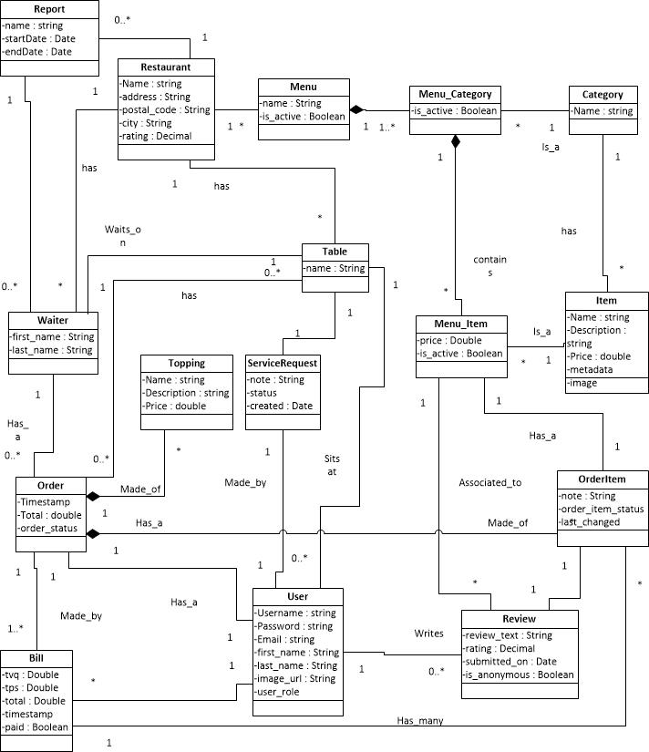

Figure 3‑1 Domain Model

# System Sequence Diagrams

## SSD25.1 Place Order

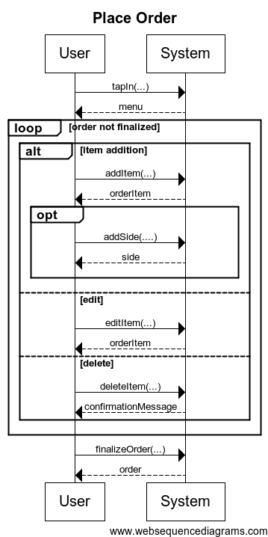

Figure 4‑1 SSD25.1 Place Order System Sequence Diagram

## SSD27.1 Manage Menu

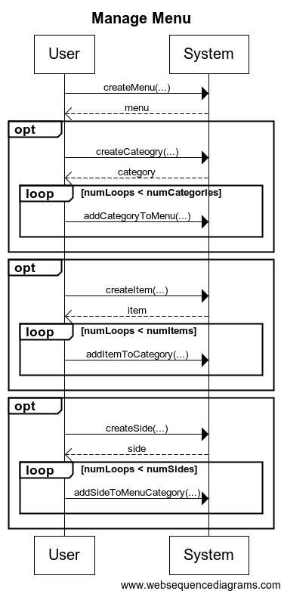

Figure 4‑2 SSD27.1 Manage Menu System Sequence Diagram

## SSD34.1 Service Request



Figure 4‑3 SSD34.1 Service Request

## SSD34.2 Service Request Response



Figure 4‑4 SSD34.2 Service Request Response

## SSD35.1 Login to Personal Profile



Figure 4‑5 SSD35.1 Login to Personal Profile

## SSD39.1 Submit a Review

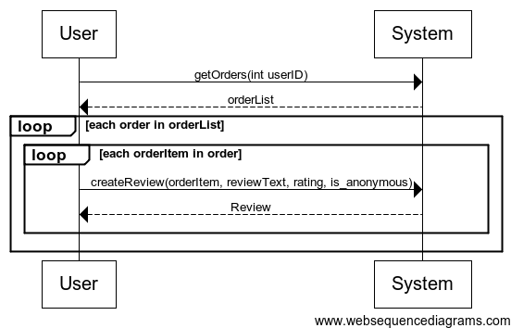

Figure 4‑6 SSD39.1 Review System Sequence Diagram

# System Operations

## SO25 Place Order

|  |
| --- |
| **System** |
| +addItem(…)  +addSide(…)  +editItem(…)  +deleteItem(…)  +finalizeOrder(…) |

## SO27 Manage Menu

|  |
| --- |
| **System** |
| +createMenu(…)  +createCategory(…)  +addCategoryToMenu(…)  +createItem(…)  +addItemToCategory(…)  +createSide(…)  +addSideToMenuCategory(…) |

## SO34 Service Request

|  |
| --- |
| **System** |
| +Cancel(int)  +CancelConfirmed(service_request)  +Complete(int)  +CompleteConfirmed(service_request)  +Create( )  +Create(service_request)  +Index( ) |

## SO35 Login to Personal Profile

|  |
| --- |
| **System** |
| +LogOn()  +LogOn(…) |

## SO39 Submit a Review

|  |
| --- |
| **System** |
| +getOrders(…)  +createReview(…) |

# Operation Contracts

## OC25 Place Order

### OC25.1 addItem()

Contract: addItem()

Operation: addItem(…)

Preconditions:

1. A user is authenticated with the system.
2. The user has selected a menu to order from.

Postconditions:

1. An order *o* has been created.
2. The order item *oi* has been created.
3. *oi* has been associated with *o*.

### OC25.2

Contract: addSide ()

Operation: addSide (…)

Preconditions:

1. A user is authenticated with the system.
2. The user has selected a menu to order from.
3. The user has selected a menu item to order.

Postconditions:

1. An order *o* has been created.
2. The order item *oi* has been created.
3. The side *s* has been created.
4. The side *s* is now associated to *oi*.
5. The order item *oi* is associated with *o*.

### OC25.3

Contract: editItem ()

Operation: editItem (…)

Preconditions:

1. A user is authenticated with the system.
2. The user has placed an order *o* with at least one order item *oi*.

Postconditions:

1. The order item *oi* is disassociated from *o*.
2. A new order item *oi2* is created.
3. *oi2* is associated with *o.*

### OC25.4

Contract: deleteItem ()

Operation: deleteItem (…)

Preconditions:

1. A user is authenticated with the system.
2. The user has placed an order *o* with at least one order item *oi*.

Postconditions:

1. The order item *oi* is disassociated from *o*.

### OC25.5

**Contract:** finalizeOrder ()

**Operation:** finalizeOrder (…)

**Preconditions:**

1. A user is authenticated with the system.
2. The user has placed an order *o* with at least one order item *oi*.

**Postconditions:**

1. The restaurant is notified off the order *o*.

## OC27 Manage Menu

### OC27.1

Contract: createMenu()

Operation: createMenu(…)

Preconditions:

1. A user is authenticated with the system.
2. The user has the role: “admin”, “restaurant”, or “developer”.
3. The user specifies a restaurant and menu name.

Postconditions:

1. The menu *menu* has been created.
2. *menu* has been associated with the given restaurant.

### OC27.2

Contract: createCategory()

Operation: createCategory(…)

Preconditions:

1. A user is authenticated with the system.
2. The user has the role: “admin”, “restaurant”, or “developer”.
3. The user specifies a category name.

Postconditions:

1. The category *cat* has been created.
2. *cat* has been associated with the menu *menu*.

### OC27.3

Contract: addCategoryToMenu()

Operation: addCategoryToMenu(…)

Preconditions:

1. A user is authenticated with the system.
2. The user has the role: “admin”, “restaurant”, or “developer”.
3. The user chooses a category to be added to the menu.

Postconditions:

1. *cat* has been associated with the menu *menu*.

### OC27.4

Contract: createItem()

Operation: createItem(…)

Preconditions:

1. A user is authenticated with the system.
2. The user has the role: “admin”, “restaurant”, or “developer”.
3. The user specifies name, description, and price for the item

Postconditions:

1. The item *item* has been created.
2. *item* has been associated with *cat*.

### OC27.5

Contract: addItemToCategory()

Operation: addItemToCategory (…)

Preconditions:

1. A user is authenticated with the system.
2. The user has the role: “admin”, “restaurant”, or “developer”.
3. The user chooses an item to be added to a category.

Postconditions:

1. *item* has been associated with the category *category*.

### OC27.6

Contract: createSide()

Operation: createSide(…)

Preconditions:

1. A user is authenticated with the system.
2. The user has the role: “admin”, “restaurant”, or “developer”.
3. The user specifies a name for the side.

Postconditions:

1. The side *side* has been created.
2. *side* has been associated with the *menuCategory* association.

### OC27.7

Contract: addSideToMenuCategory()

Operation: addSideToMenuCategory (…)

Preconditions:

1. A user is authenticated with the system.
2. The user has the role: “admin”, “restaurant”, or “developer”.
3. The user chooses a side to be added to a menu-category association.

Postconditions:

1. *side* has been associated with the menu-category *menuCategory*.

## OC34 Service Request

### OC34.1

**Contract:** Create

**Operation:** Create(service_request)

**Cross References:** UC34.1 Service Request

**Preconditions:**

1. The user with role restaurant is logged in and authenticated.
2. The user is associated to a table instance.

**Postcondition:**

1. An instance of service_request *sr*, with status OPEN, was created (instance creation).
2. *sr* was associated to Table (formation of association).

### OC34.2

**Contract:** CompleteConfirmed

**Operation:** CompleteConfirmed(service_request)

**Cross References:** UC34.2 Service Request Response

**Preconditions:**

1. A user with role restaurant is logged in and authenticated.
2. A restaurant client has created an instance of service_request *sr* with status OPEN.

**Postcondition:**

1. The status of *sr*  is set to COMPLETE.

### OC34.3

**Contract:** CancelConfirmed

**Operation:** CancelConfirmed(service_request )

**Cross References:** UC34.2 Service Request Response

**Preconditions:**

1. A user with role restaurant is logged in and authenticated.
2. A restaurant client has created an instance of service_request *sr* with status OPEN.

**Postcondition:**

1. The status of *sr*  is set to CANCELLED.

## OC35 Login to Personal Profile

### OC35.1

**Contract:** LogOn

**Operation:** LogOn(…)

**Cross References:** UC35.2 Login to Personal Profile

**Preconditions:**

1. The user is currently not logged in.
2. The user is associated to a table instance.

**Postcondition:**

1. An instance of user *usr*, with a valid authentication cookie, was created.
2. *usr* was associated to Table (formation of association).

## OC39 Submit a Review

### OC39.1

Contract: getOrders ()

Operation: getOrders (…)

Preconditions:

1. A user is authenticated with the system.
2. The user has at least one order that has been processed and finalized by the restaurant.
3. This order has at least one order item that has not yet been reviewed.

Postconditions:

1. A list of orders that have not been reviewed was created and returned to the user

### OC39.2

Contract: createReview ()

Operation: createReview (…)

Preconditions:

1. A user is authenticated with the system.
2. The user selects an order to review.
3. The user selects the order items which he wants to review

Postconditions:

1. A review has been created for each order item selected

# ****Appendix A References****

x

|  |  |
| --- | --- |
| [1] | Atlassian. (2012, December) Issue & Project Tracking Software. [Online]. <http://www.atlassian.com/software/jira/overview> |
| [2] | K. Anderson, C. Donato, J.Hum, M. Levkovsky, A. Lloyd, P. Modafferi, "F.S.T.S SRS," Concordia University, Montreal, SRS Document v6.16, 2012. |
| [3] | Microsoft. (2012, December) C# Coding Conventions (C# Programming Guide). [Online]. <http://msdn.microsoft.com/en-us/library/vstudio/ff926074.aspx> |
| [4] | Assembla, Inc. (2012, Decemeber) Assembla; Home Page. [Online]. <https://www.assembla.com/home> |
| [5] | K. Anderson, C. Donato, J.Hum, M. Levkovsky, A. Lloyd, P. Modafferi, "F.S.T.S," Concordia University, Montreal, Canada, Vision Document, v6.16, 2012. |

x

# Appendix B Prototypes

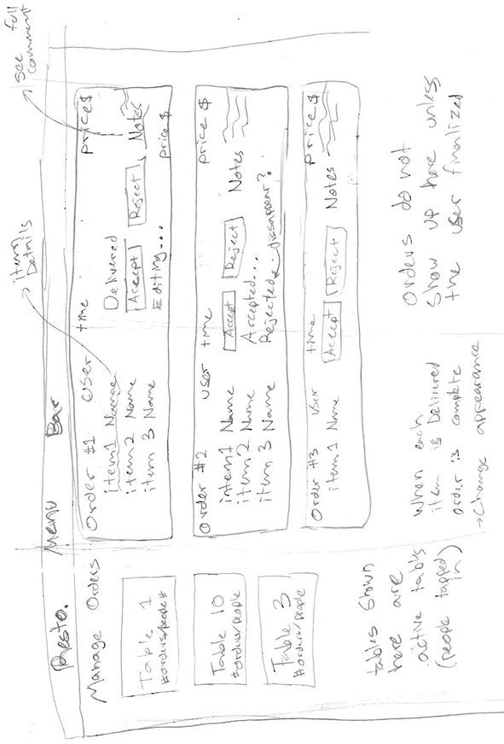

Figure B-1 Manage Order Prototype

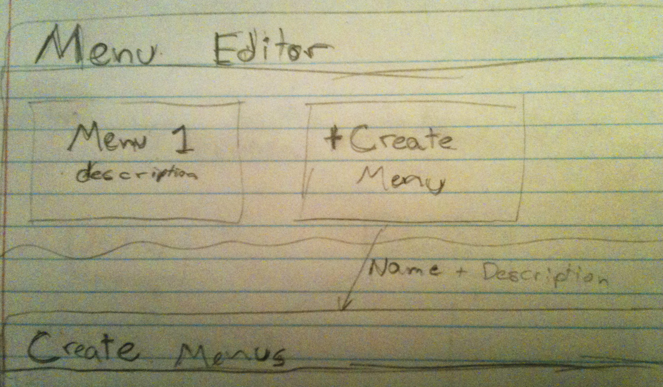

Figure B-2 Menu Editor Main Page

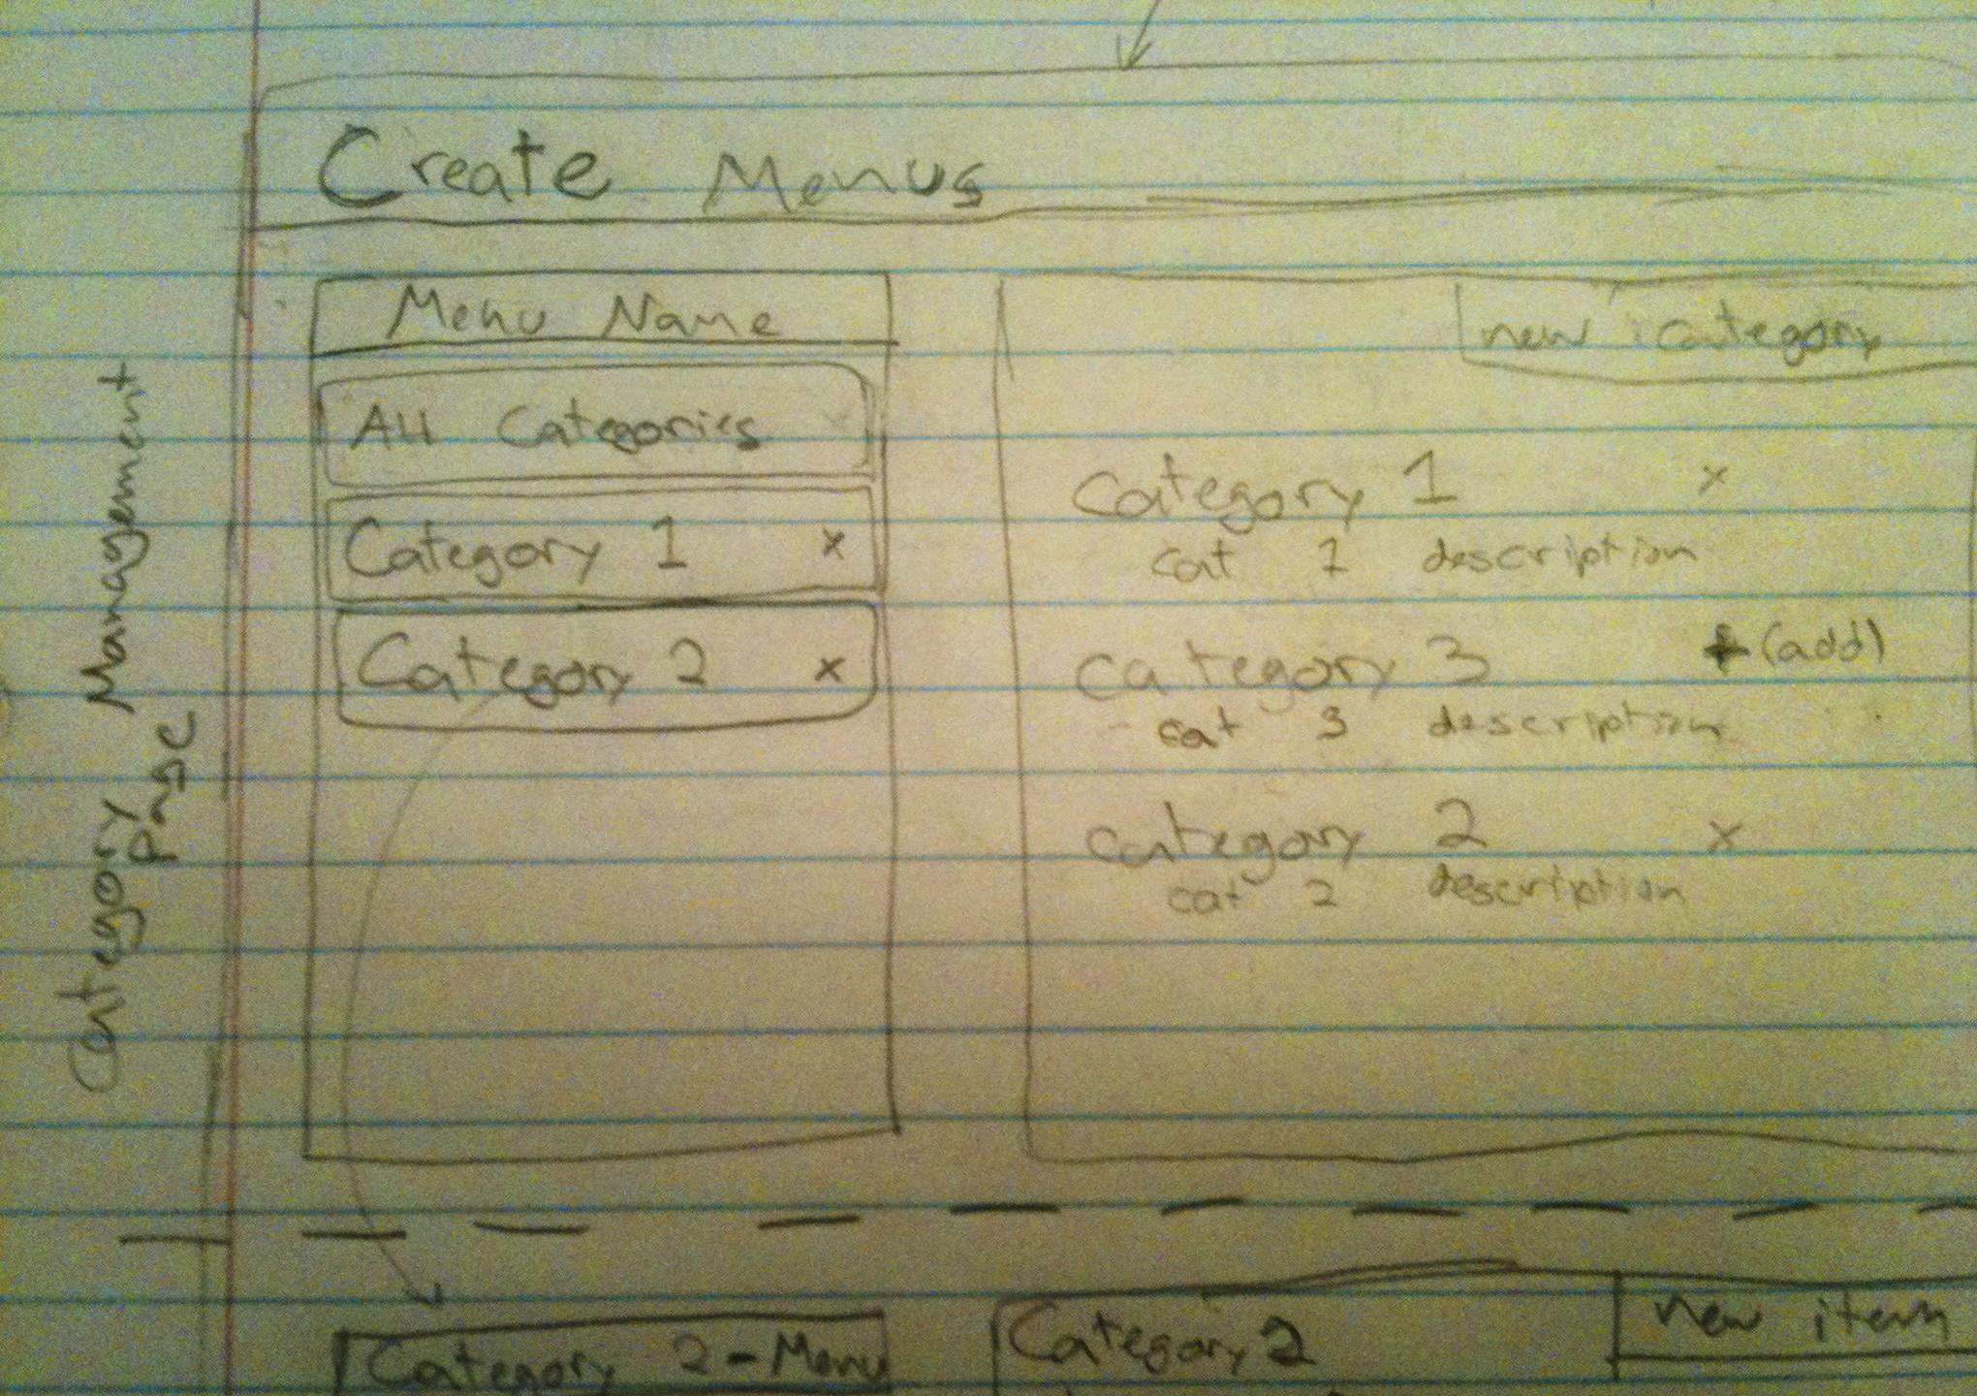

Figure B-3 Category Management Page

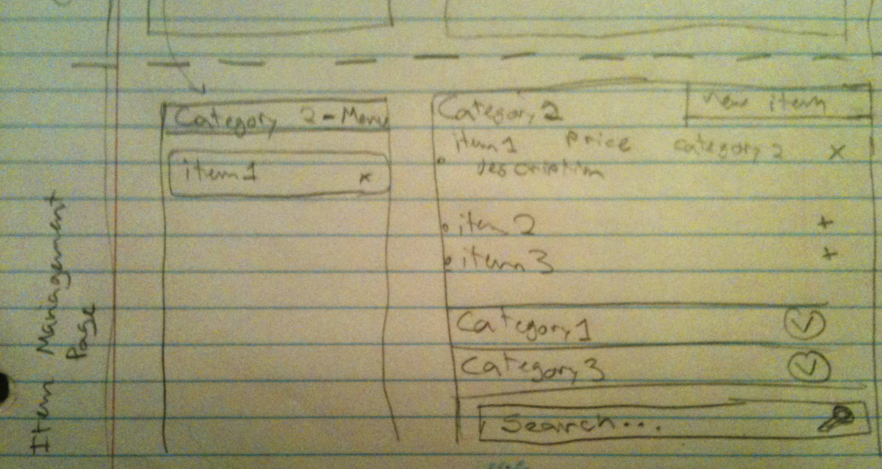

Figure B-4 Item Management Page

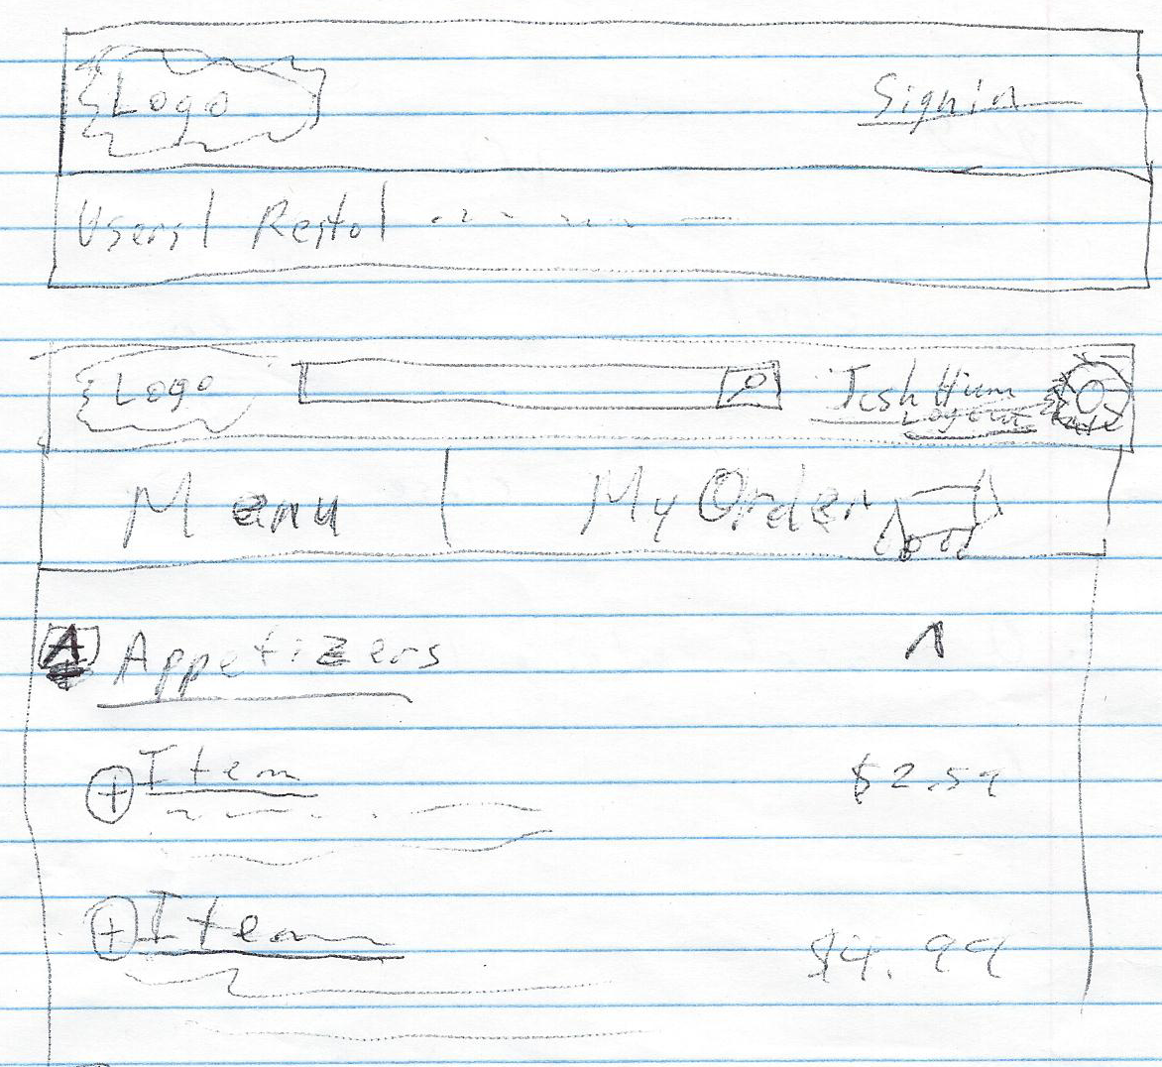

Figure B-5 Order From Menu

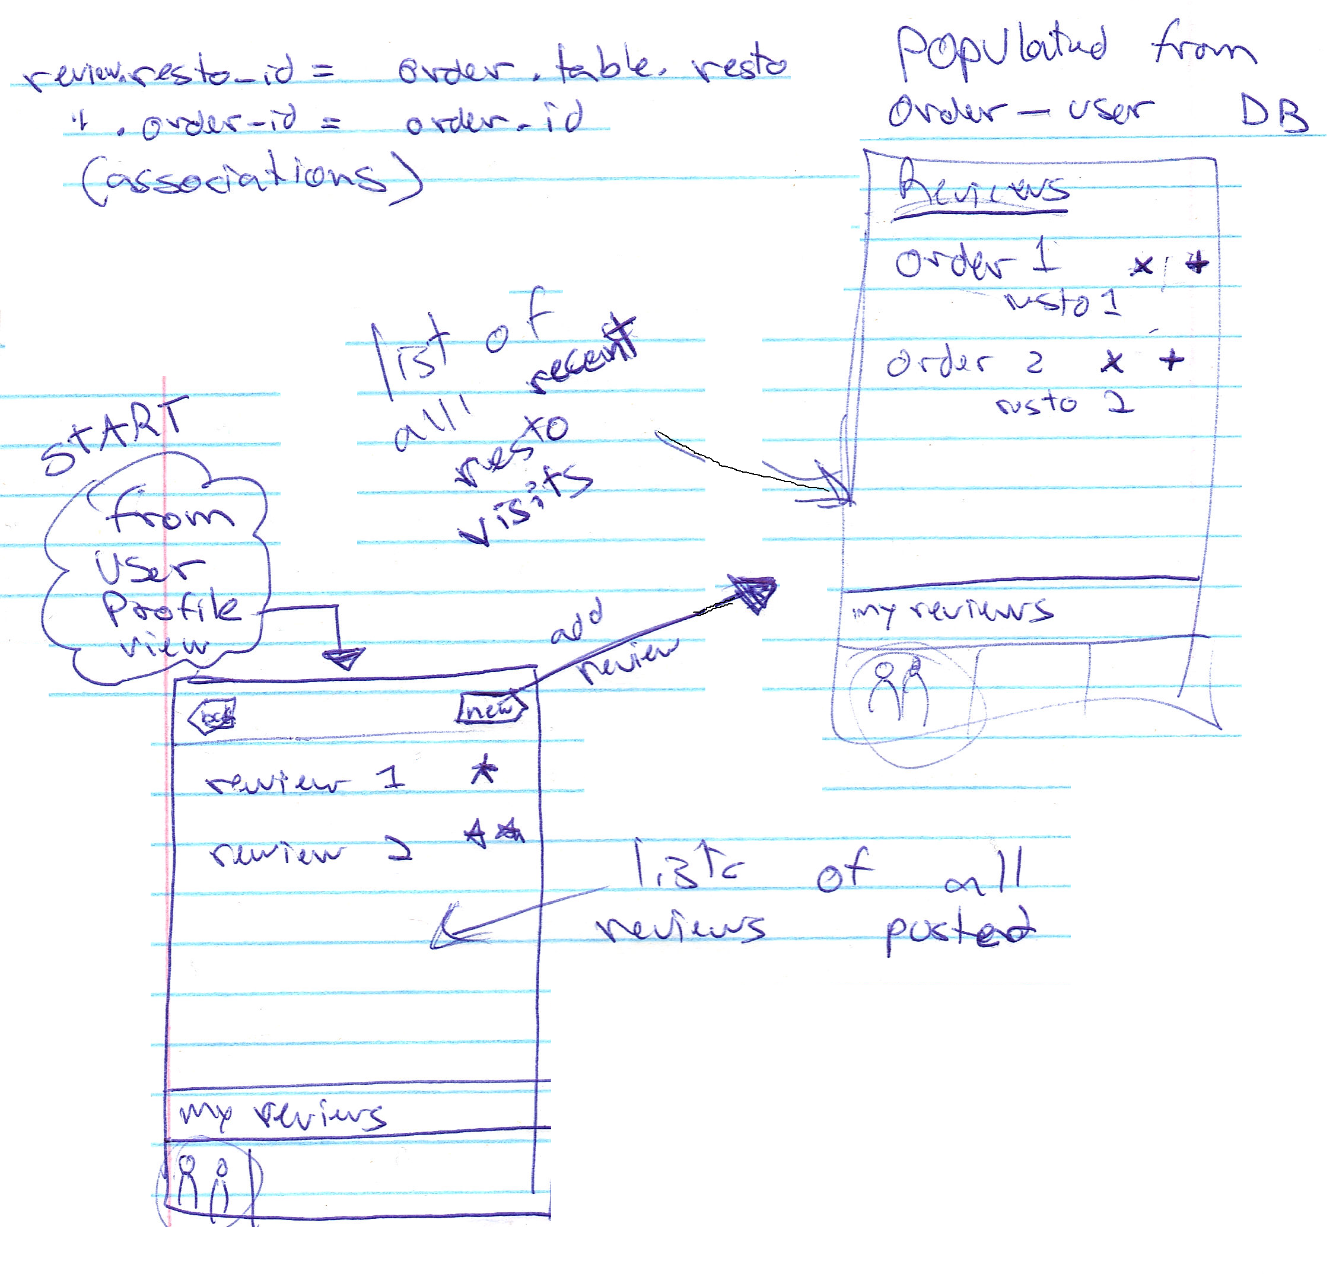

Figure B- 6 Leave Review

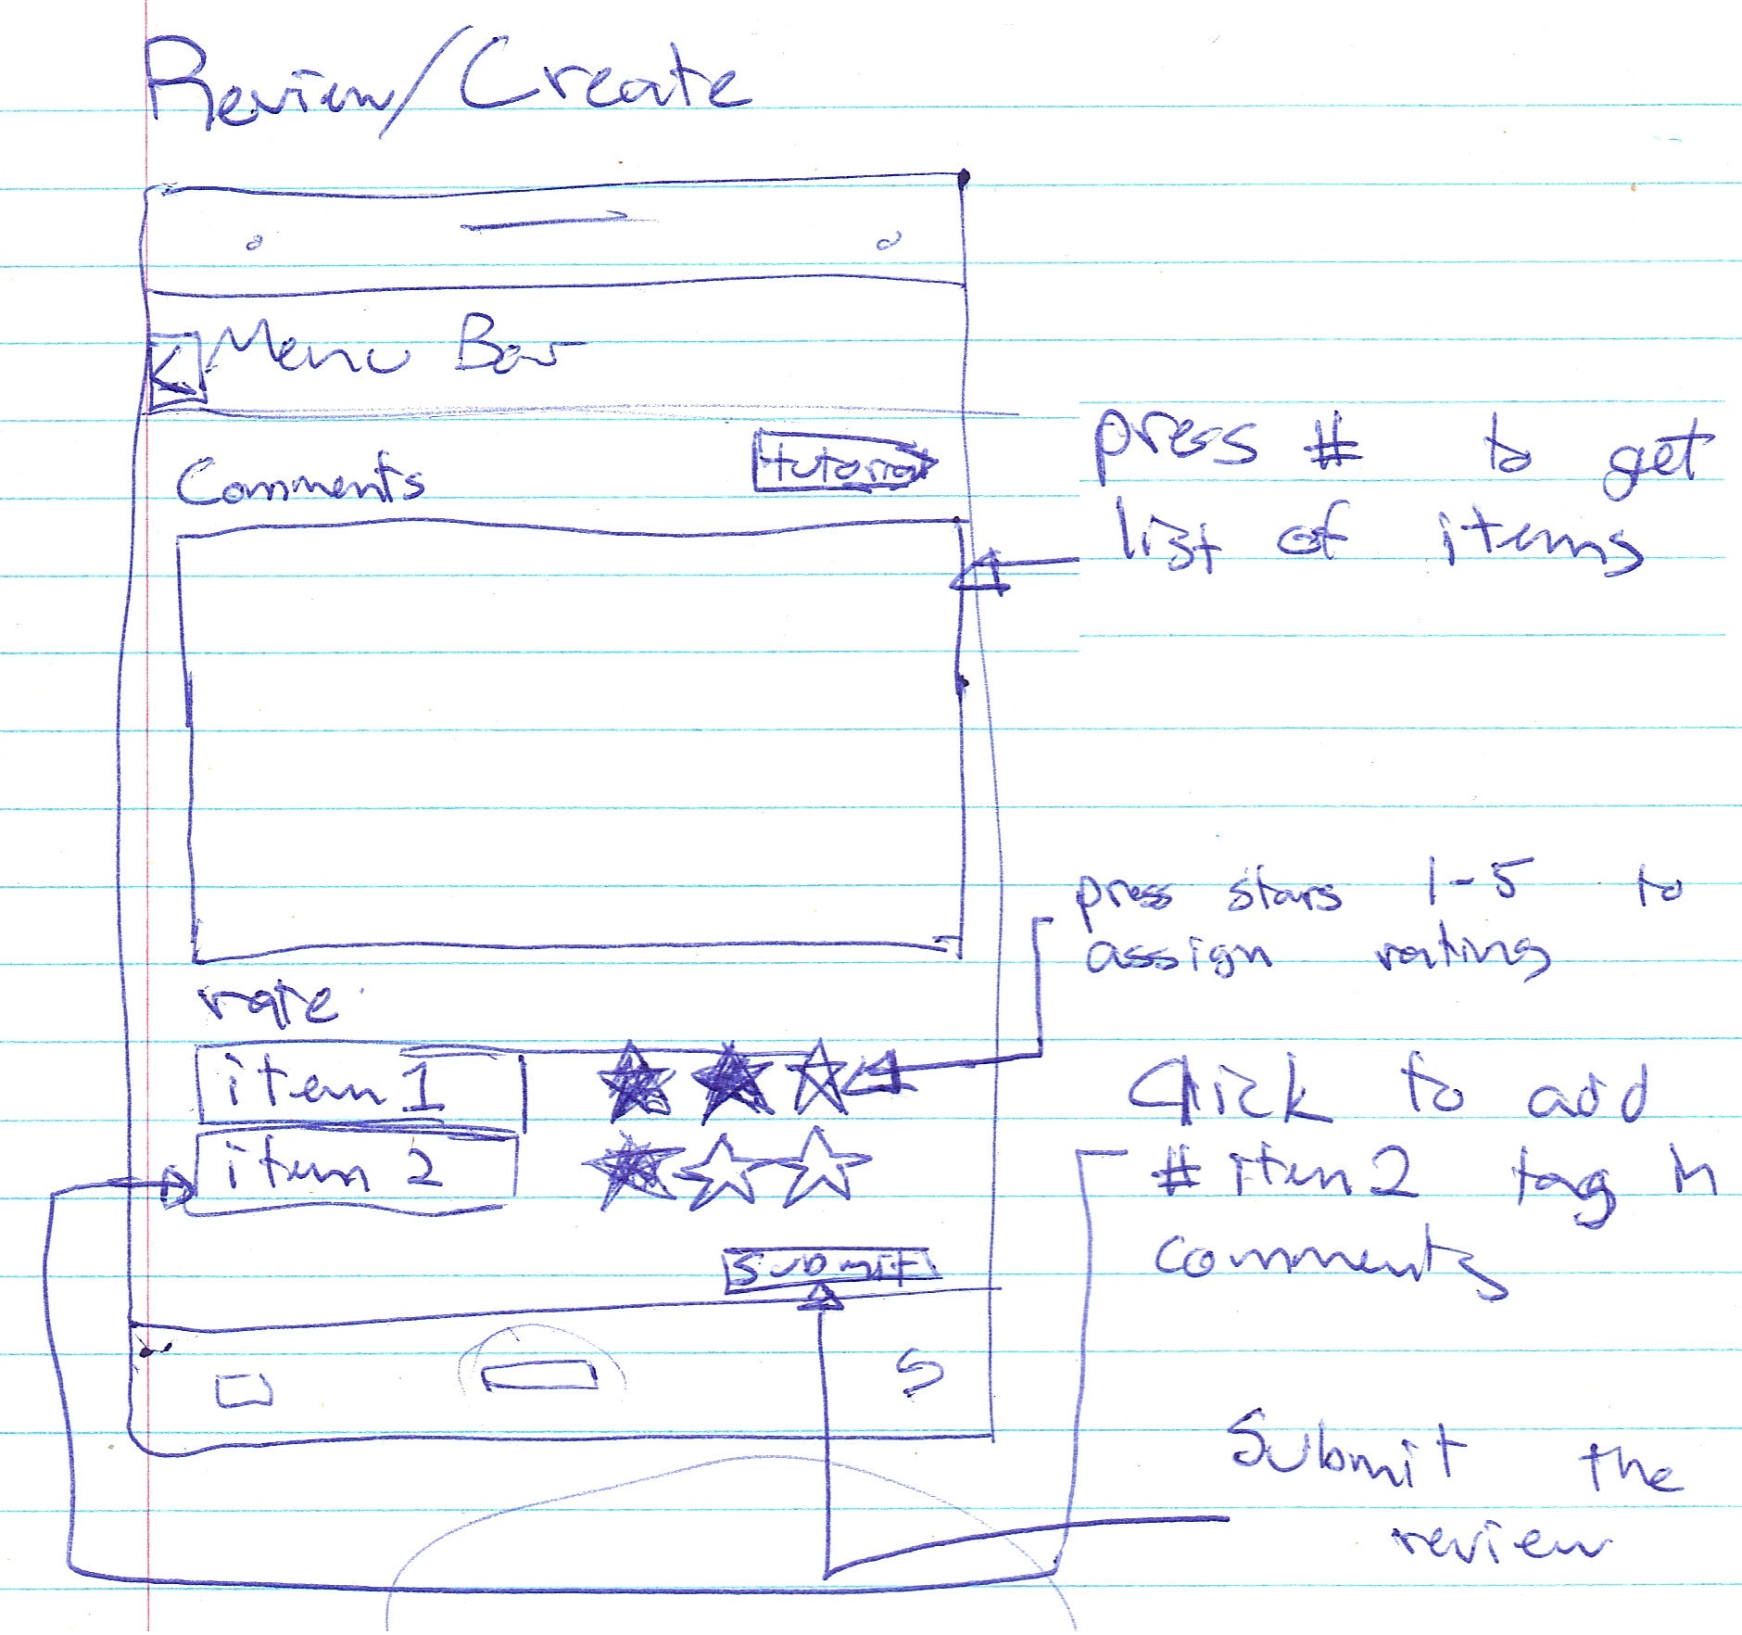

Figure B- 7 Create Review